ERCCA:

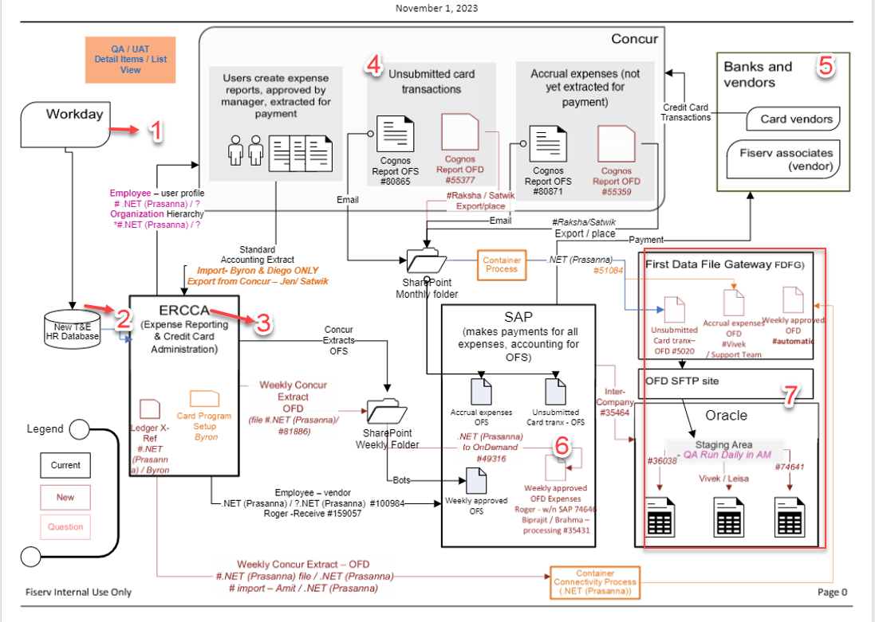

1. To create a Concur profile, we will need certain information from **Workday/Mini master data.** This includes details such as first and last name, cost center, and company code, which can be found in the PA0001 Infotype. Additionally, communication details like your SAP ID or email address can be found in PA105 Infotype and

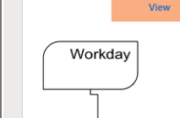

1. Once Data is stored in **T&E HR database**:

1. Employee information for expense-related and credit card information for card transactions will be used to run the **ERRCCA** job.

All this information will get copied from SAP table/T&E HR database to concur.

Once this information is updated.

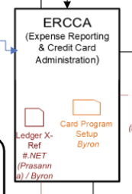

1. A) Employees or users can **create expense reports and submit them for managerial approval**. Once approved, these reports will be processed for payments, and the transactions will be followed by standard accounting extracts (SAE).
2. If the user has used their credit card for personal expenses, their Concur dashboard will show these transactions as unsubmitted items or **unsubmitted card transactions**. A notification email will be sent to SharePoint on the monthly folder to follow up on these transactions.

As per the diagram below,

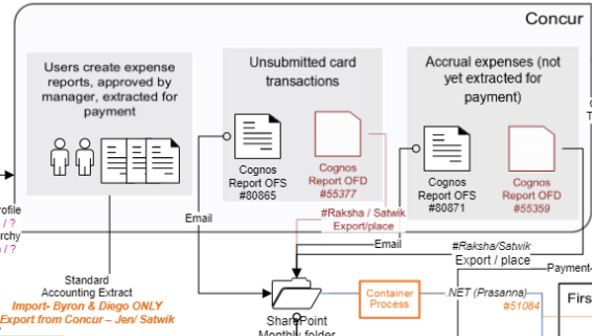

Transactions should be OFS and OFD   
OFC is FTE transactions(Full-time employees) such as users will be part of our company codes/our active cost center  
OFD: Outside employees/users will not be part of our company codes such cross company code users.(From ORACLE Data base) 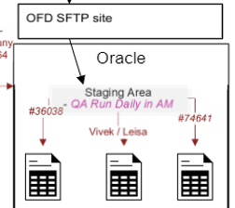

1. **Accrual expenses** are nothing but future-dated transactions for RFS and RFD.
2. Credit Card Transactions: are nothing but Pending card transactions.

Indeed Credit cards will be given to Card vendors and our vendors which are onboarded as FTE through HR master.

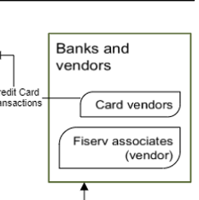

1. Let us say all transactions got approved, audited, and Posted in SAP.  
   Now payment needs to be paid: that is through SAP.

**SAP** will make payments for all expenses.

As I mentioned above there were two kind of transactions SAP had to be paid I.e Actual expenses/Cash/personal exp and Pending card /Credit card transactions  
Actual transactions will paid to users Bank accounts( Salary accounts) via F110 Automatic payment program(APP).

Card Transactions will be paid/Filled to Credit cards dues on specific dates every month(for Knowledge late payments will be charged).

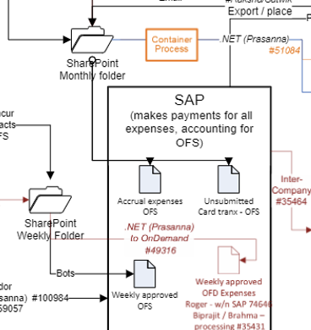

As per the above diagram.

ERCCA will be sending the file weekly basis to SAP for payment( Here BOTs also sending same data that ERCCA was sending.

1. Cross-company code/ Inter company transactions

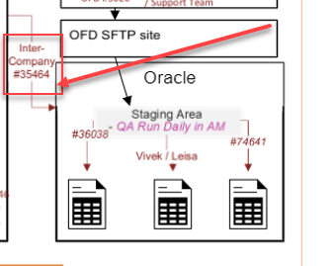

Cross – Company code transactions mean the user relates to one company code(Oracle) which is not part of the Fiserv company codes list and this user paid by FISERV along with FISERV Company users through the SAP Payment program F110.